**Print Book Evaluation**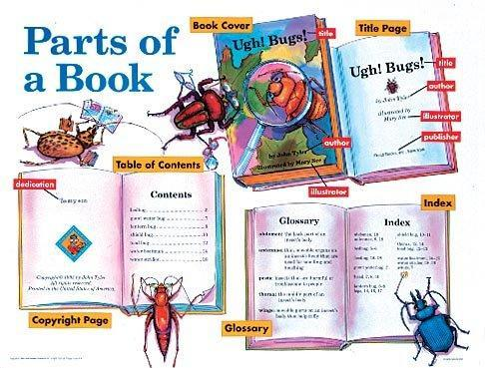

**Parts of a book**

Title

Author

Publisher

Illustrator

Preface

Table of Contents

Appendix

Glossary

Index

Text

Title page

Bibliography

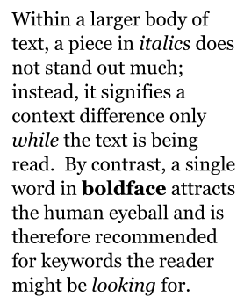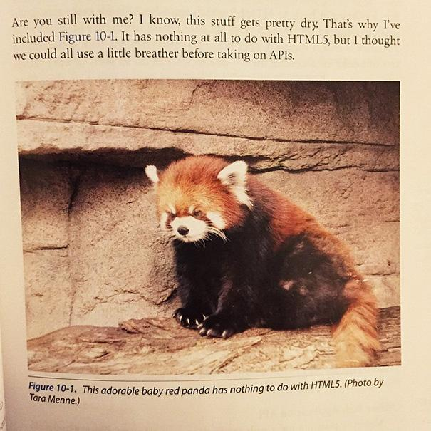

**Pedagogical aids**

Images

Examples

Bold-faced terms

Boxes

Chapter glossaries

Chapter summaries

Demonstrations

Discussion questions

Italics for emphasis

Learning checks

Learning objectives

Outlines

Pronunciation guides

Review exercises

Running glossaries

Section summaries

**Detailed reference guide for parts of a book, see Wikipedia article, “Book design”** [**https://en.wikipedia.org/wiki/Book_design**](https://en.wikipedia.org/wiki/Book_design)